

XMICRO-BP8
Technical Manual
Features:

- 8-slot XMICRO backplane
- Address-based card selection with configurable location
- Power-on reset circuit
- Active backplane termination
- Compatible with ATX power supplies

Functional Description:

The XMICRO-BP8 is a backplane providing eight slots to interconnect and supply power to XMICRO-compatible cards. A card select circuit asserts a slot-specific signal when the address lines on the bus match a configurable address range. Slot-specific interrupt request signals are also routed to the bus, giving each slot a predefined set of resources. A configurable active termination network is built into the backplane section to improve signal integrity. Power is supplied by a standard ATX PSU and delivered to each slot position. A power-on reset circuit is built in to initialize the system once the power supply has stabilized.

Tables of Information

Table 1 – Card Configuration
Setting | Function
JP1/2 | Select backplane termination voltage
JP3 | Enable 2.85V termination voltage regulator
JP4 | Enable card select circuit
JP5 | Select reset circuit trigger
JP6 | Select reset circuit voltage rail
JP7 | Enable reset circuit
S2 | Card Select address

Table 2 – Power Rail Current Capacity*
Rail | Maximum Total Current | Maximum Current Per Slot
+12V | 6.0A | 2.5A
+5V | 6.0A | 5.0A
+3.3V | 6.0A | 2.5A
-12V | 2.0A | 1.0A
+5VSB | 2.0A | 1.0A
*Maximum current is also limited by power supply specifications.
Card Select

The card select system allocates $100 bytes of address space to each card slot. The CSX signal for a given slot is asserted if the bus address lines A<19..8> match those of the address range of that slot. Bits A<19..12> of that address range can be configured with DIP switch S2 to meet the needs of any given system configuration. Bits A<11..8> of that range match the card to be selected. The card select system can also be disabled entirely by removing the jumper from J4.

Example 1: We want card I/O space to occupy the address range at $01000-$017FF so S2 is set to $01.
Card 5 will be selected at $01500-$015FF

Example 2: We want card I/O space to occupy the address range at $C4000-$C47FF so S2 is set to $C4.
Card 2 will be selected at $C4200-$C42FF

Reset Circuit

The reset circuit asserts the RESET signal on the bus until 250ms after the PSU asserts its “Power Good” signal. This initializes the system to a known state only after all power rails have stabilized. It also prevents system operation while any supply rail is out of tolerance to avoid unexpected operation. It can be configured in several ways to accommodate unusual power supply systems, but should typically reset when the PG signal is asserted as shown in Figure 1. The XMICRO-BP8’s reset circuit should work in addition to any card’s onboard reset circuit, however it can be disabled by removing JP7.

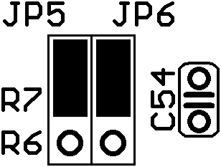  Reset on PG (Default) | 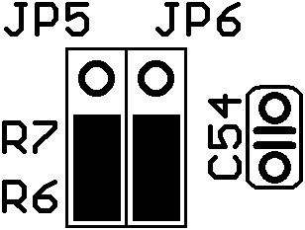  Reset on +5V Present
Figure 1 – Termination Voltage Selection

Termination

The XMICRO-BP8 contains a highly configurable backplane termination network to improve signal integrity. All of the bus’s shared signals are pulled to 2.85V through 270Ω resistors (RN1-RN12, R1, R2) at either end of the backplane. This reduces signal reflections and pulls floating signals to a known high state.

All termination resistors are socketed to allow them to be removed or have their values changed if required. The common pin of the termination resistors can also be changed with J1 and J2. When changing termination network parameters, care must be taken to avoid excessively loading the bus signals.

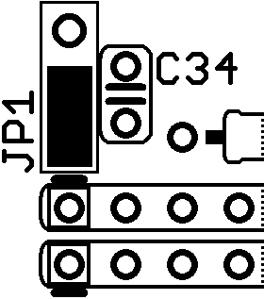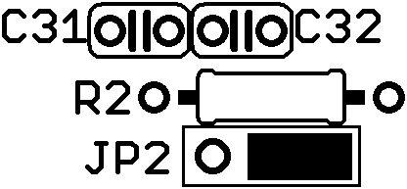  Pull bus to +2.85V (Default) | 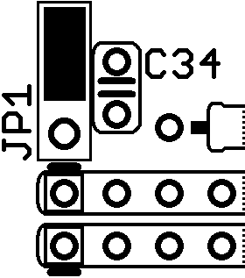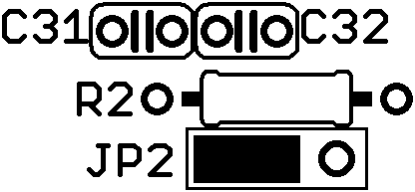  Pull bus to +5V
Figure 2 – Termination Voltage Selection

Power Supply

A standard ATX-compatible power supply is connected to J1 and provides the XMICRO-BP8 with all necessary supply rails. The supply’s internal power-on signal is used to turn the system on and off using switch S1. S1 can be bypassed by shorting J2 with a jumper or switch.

Table 2 contains maximum current ratings for the backplane. The maximum rated current limits of the PSU and backplane must be strictly observed, whichever is lower. Failure to adhere to current limits may cause damage to the system or fire.
Appendix A – Hardware V1.0

The polarity of C48 is reversed on V1.0. Since this capacitor is across a negative voltage rail, the positive pin of the capacitor must be connected to the ground pad and the negative pin to the “+” pad.

V1.0’s power-on reset circuit is unreliable and requires the following modification:

New Components
- 2x 1N4148 diode
- 1x 10K resistor
- 2x 22K resistor
- 1x 470 resistor
- 1x 220 resistor

Replacements
- R8 - 22K
- R9 - 22K
- R10 - 470
- R12 - 220

Modifications
- R11 tied to +5VSB
- Q2 Emitter to +3.3V
- Q1 Collector 10K pullup to +5VSB
- C56 diode to R9
- U9 pin 3 connect to R9 though diode

Instructions
- Cut traces on top and bottom connecting to R11 on the pad furthest from the LEDs. Connect wire on the bottom between this pad and the center pad of JP6.
- Connect wire between Q2 Emitter pad (furthest from LEDs) and C1 (furthest pad from LEDs)
- Connect a 10k resistor between JP5 and C54 pads closest to the board edge.
- Connect the anode of a diode to C56 on the pad closest to C55, connect the cathode (negative) to R9 pad closest to the LEDs.
- Cut trace between U9 pin 3 and R9. Connect the anode of a diode to U9 pin 3, connect the cathode (negative) to R9 pad closest to the LEDs.

